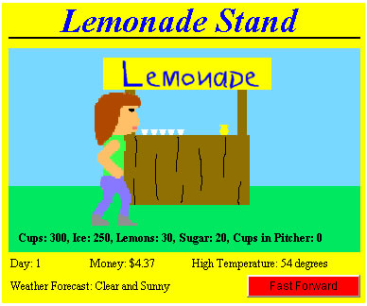
LEarning Targets

Upon Completion of this activity, students will be able to:
Employ technology in the development of strategies for solving problems in the real world.
- Students will purchase ingredients for making lemonade.
- Students will determine the cost to produce one cup of lemonade.
- Students will assess weather forecasts and customer behavior patterns to determine how much lemonade to make each day.
- Students will use an Office Excel spreadsheet to collect data and record outcomes.
- Students will write a report reflecting on their data and the outcomes.

