The difference between benefits vs. features
- Features are defined as surface statements about your product, such as what it can do, its dimensions and specs and so on.

- Benefits, by definition, show the end result of what a product can actually accomplish for the reader.

A fast internet connection is a feature,
but the ability to quickly find your way when you’re lost is a benefit.
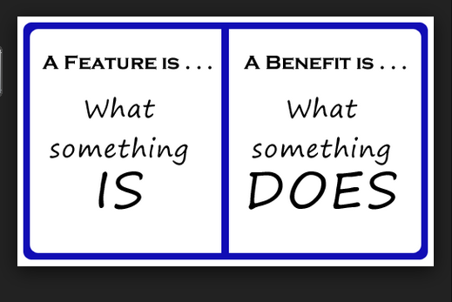
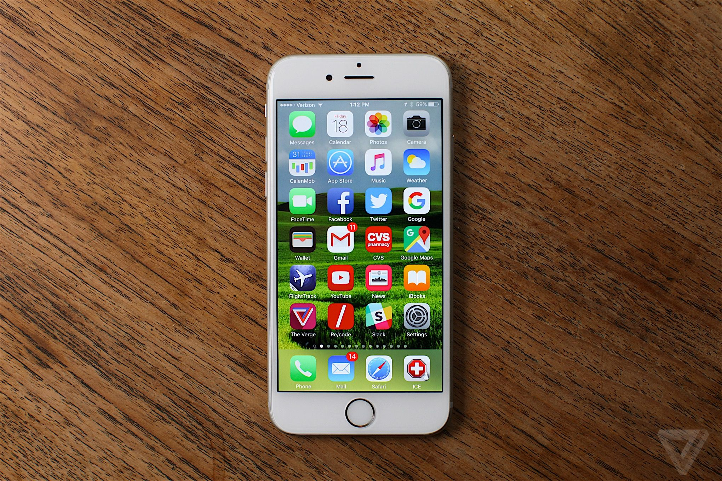
Features:
- 12 MP, 4032 x 3024 pixels, phase detection autofocus, dual-LED (dual tone) flash,
- Active noise cancellation with dedicated mic
- Siri natural language commands and dictation
- iCloud cloud service
- iCloud Keychain
- TV-out
- Maps
- Organizer
- Document editor
- Photo/video editor

Features:
Group Exercise Studio
State of the Art Equipment
Kids Club
Personal Training
Functional Training
Cycle Studio

