Manufacturer | Wholesaler | Retailer | Service
Definition: | Definition: | Definition: | Definition:
Examples: | Examples: | Examples: | Example:
Manufacturer
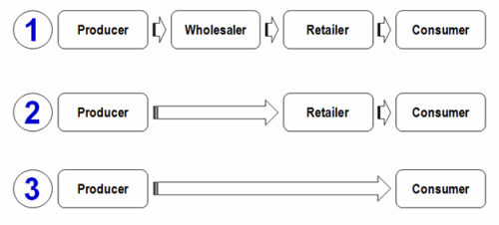
Manufacturer
Manufacturer
Manufacturer
Manufacturer

